**Week 1**

**Exercise 1: Implementing the Singleton Pattern**

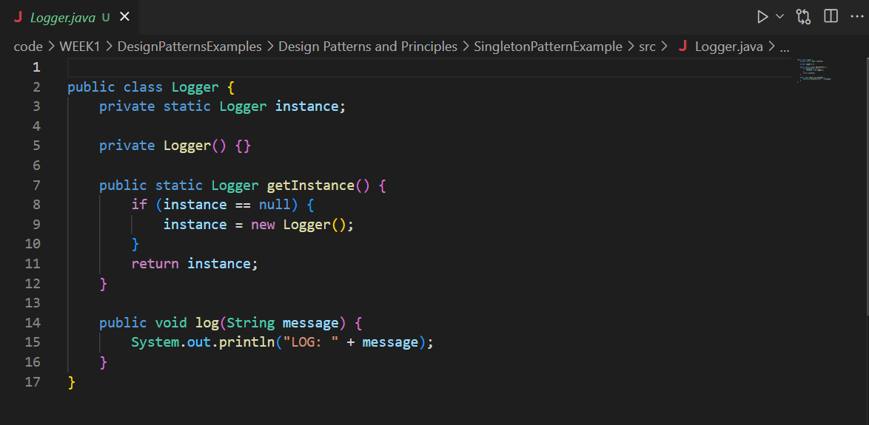

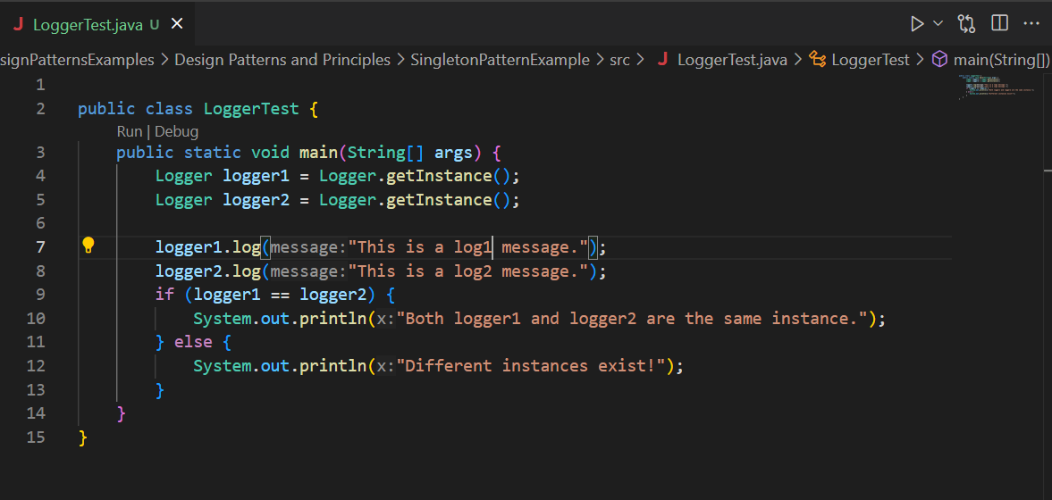

**Result:**

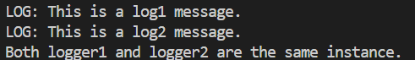

**Exercise 2: Implementing the Factory Method Pattern**

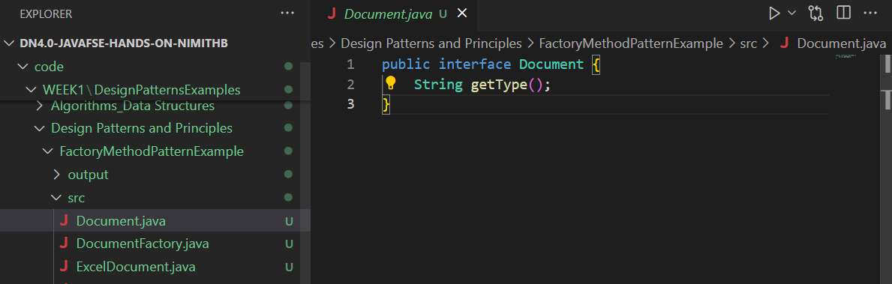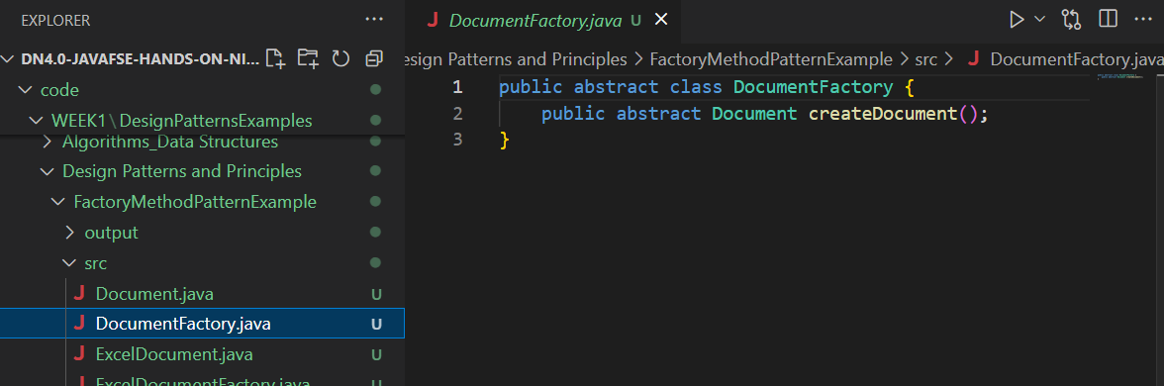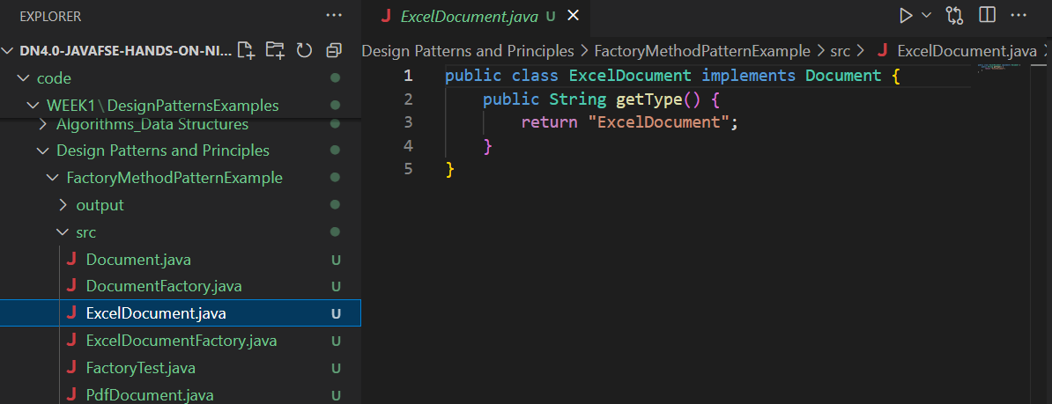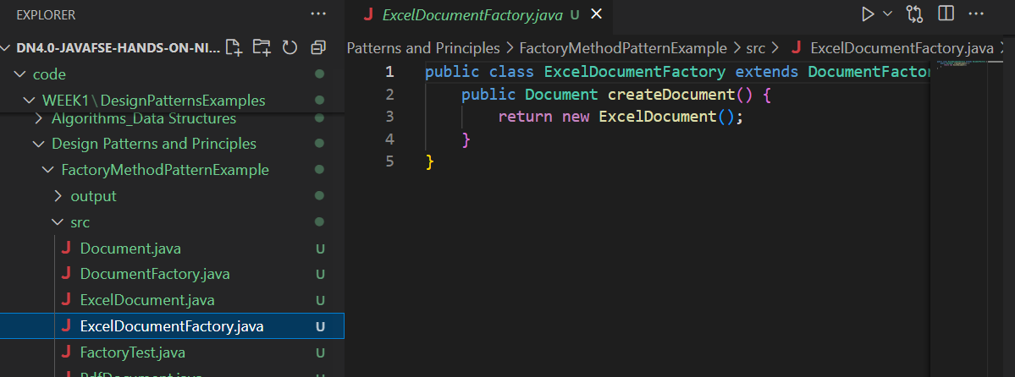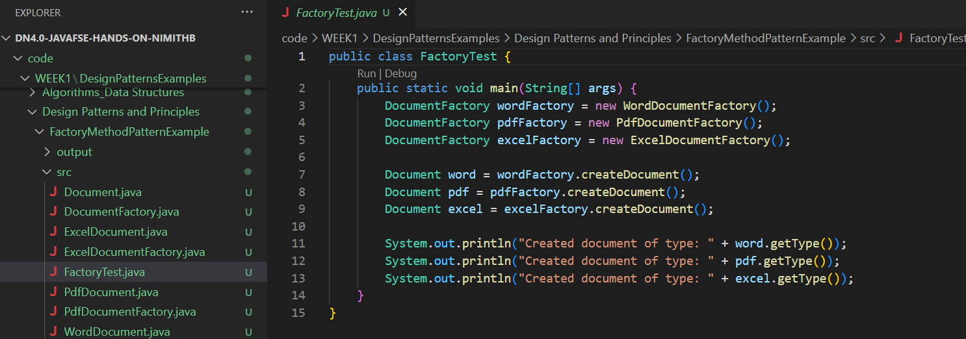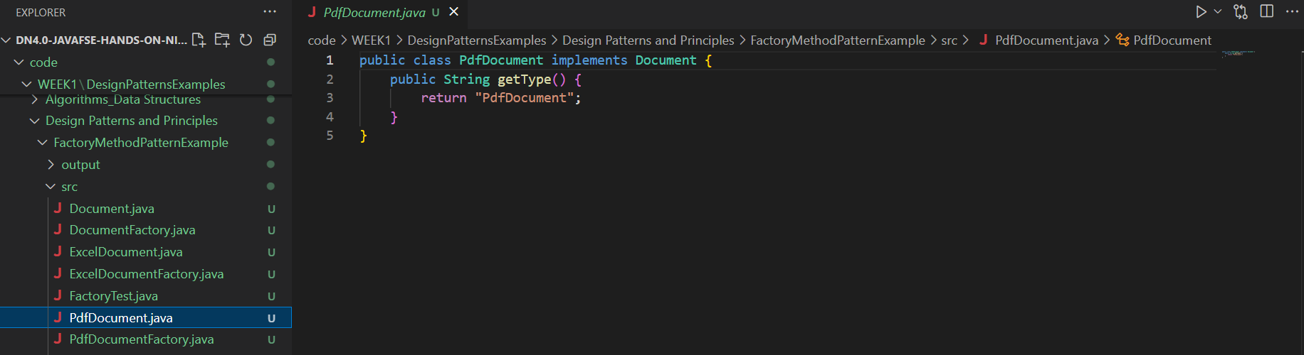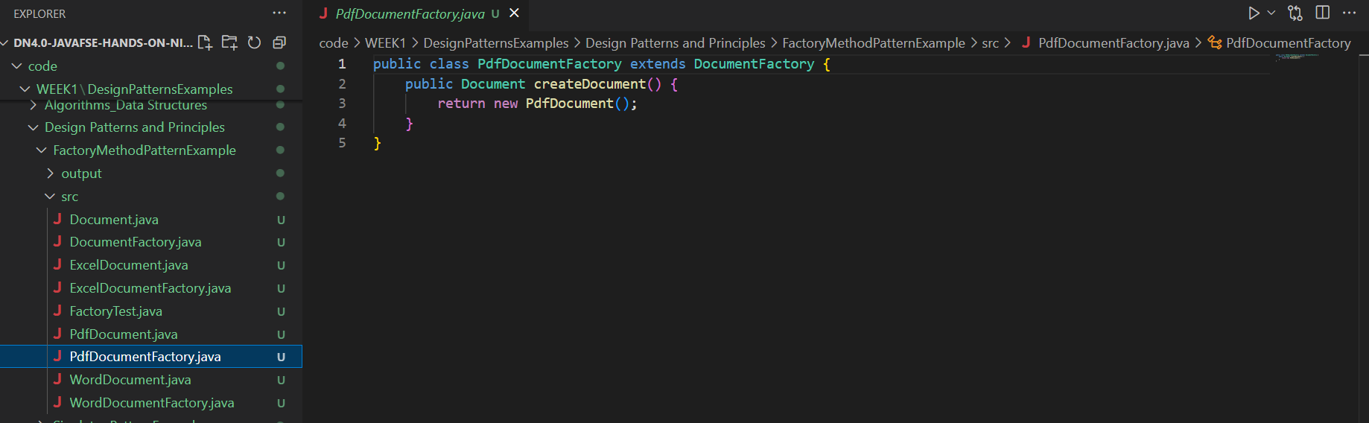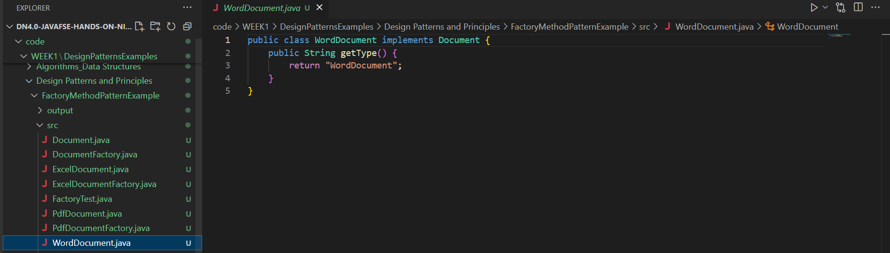

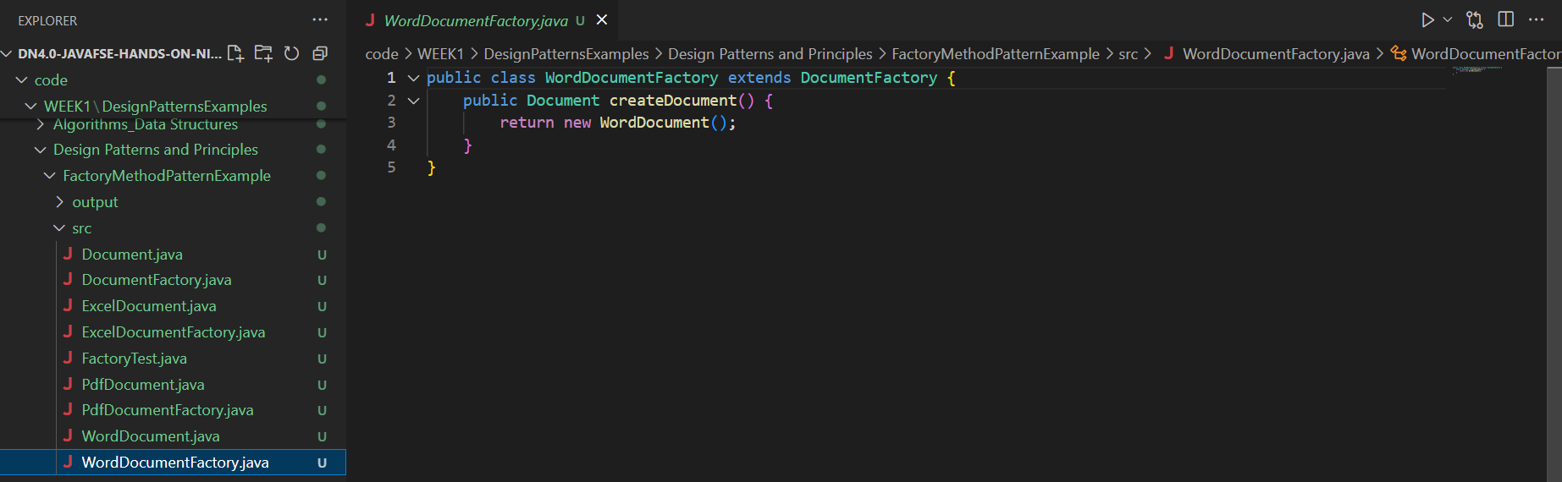

**RESULT**

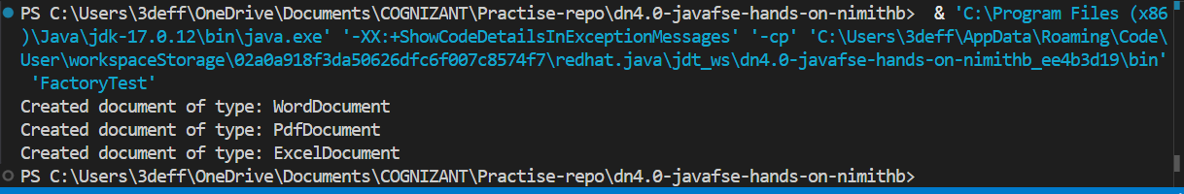

**Exercise 2: E-commerce Platform Search Function**

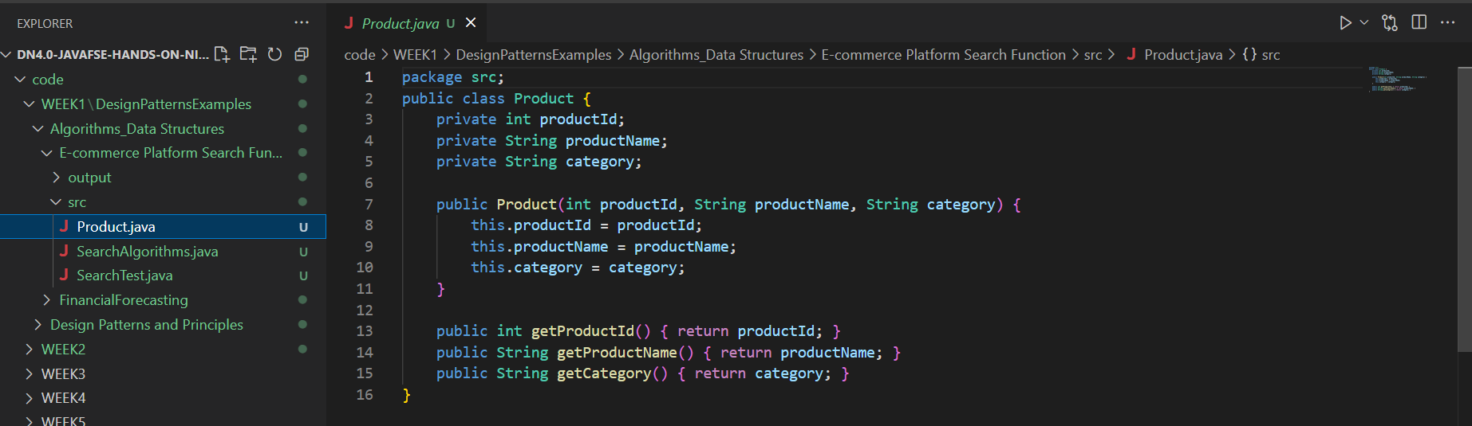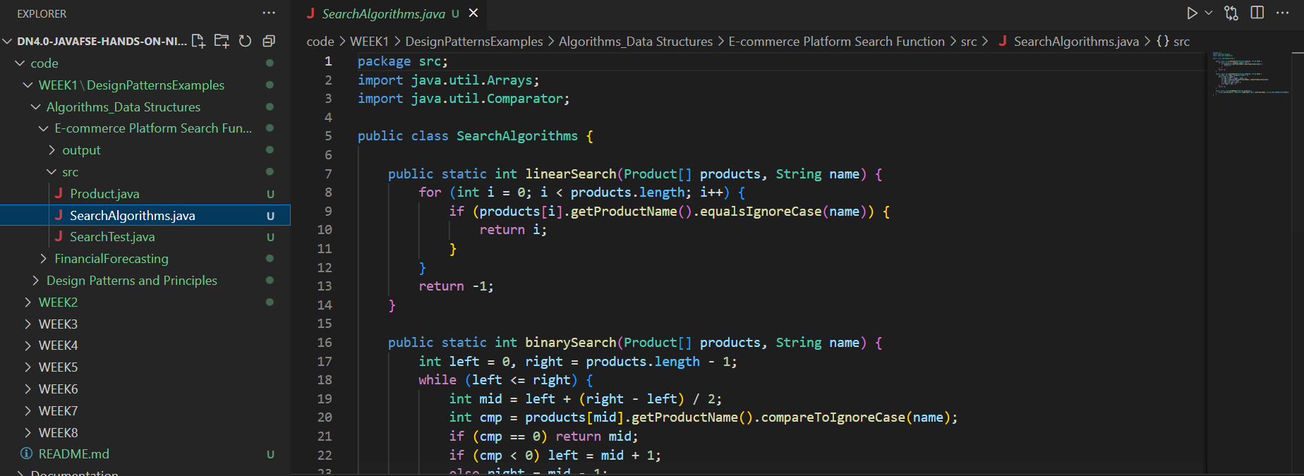

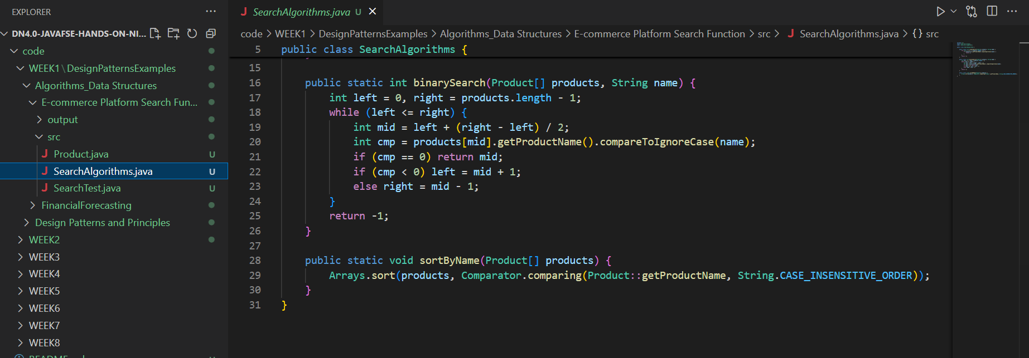

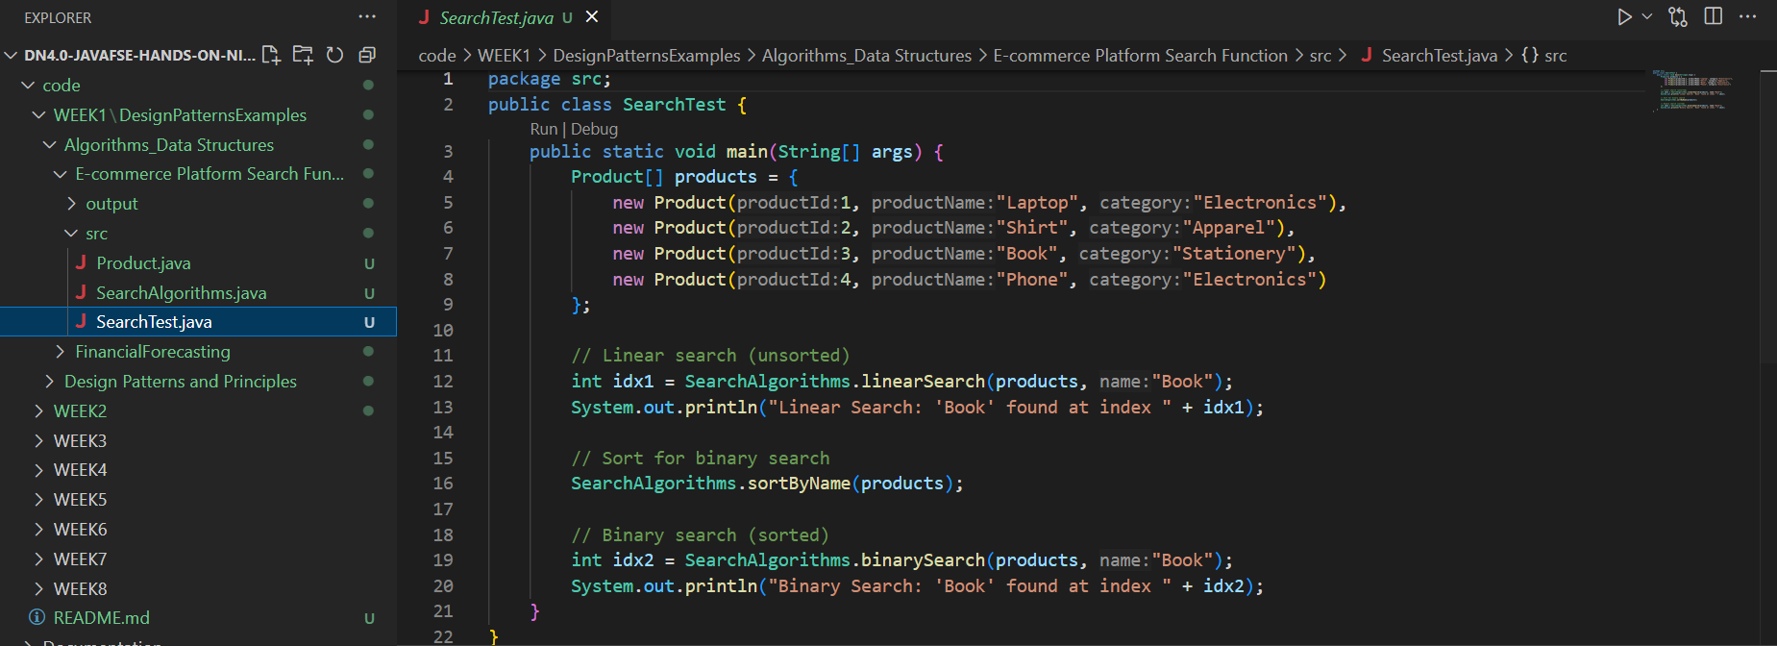

**RESULT:**



**Exercise 7: Financial Forecasting**

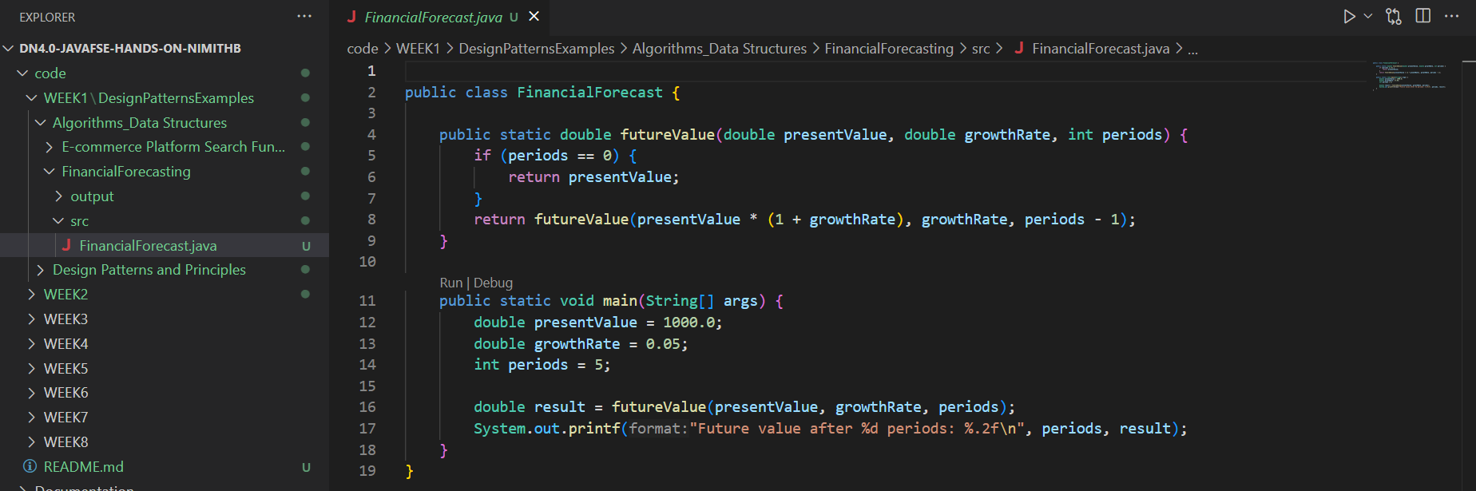

**RESULT**

